**25.ONLINE VOTING SYSTEM**

**USECASE DIAGRAM:**

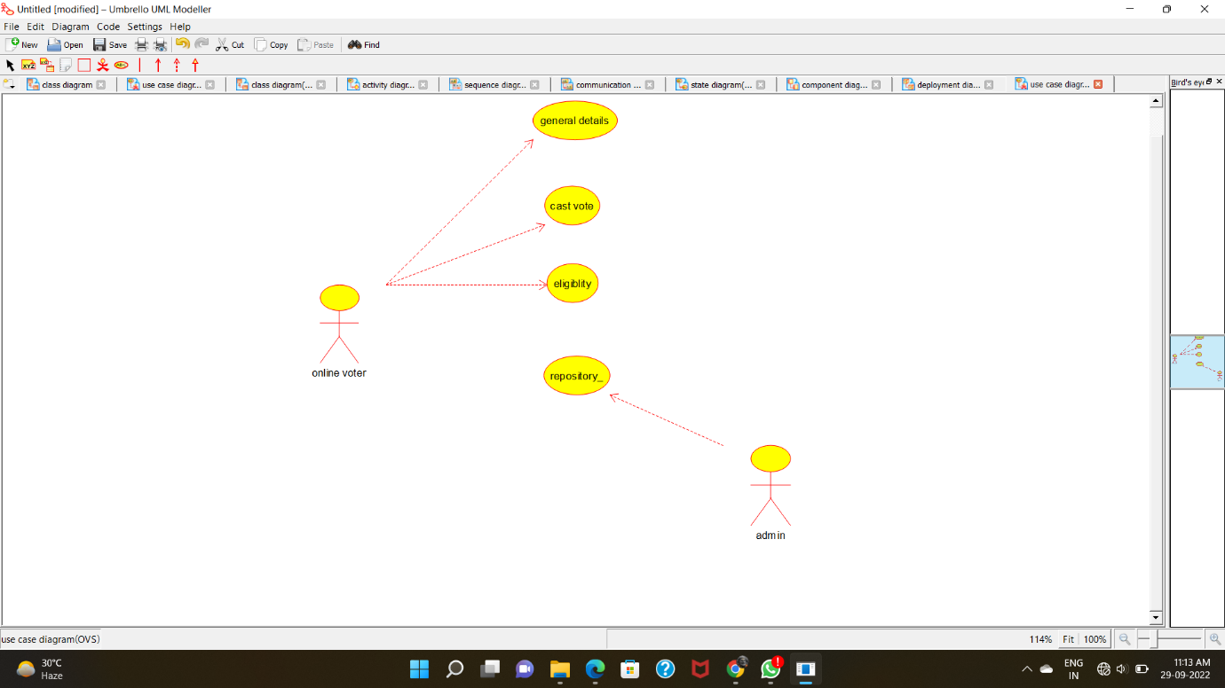

**CLASS DIAGRAM:**

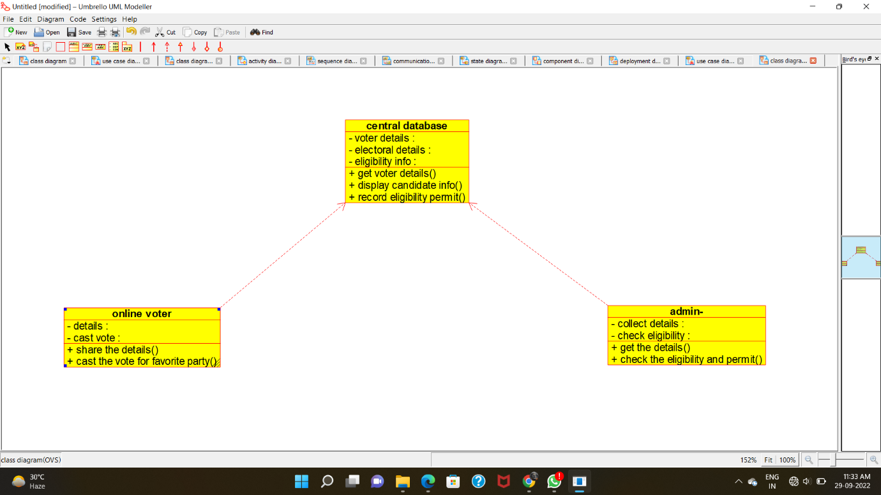

**ACTIVITY DIAGRAM:**

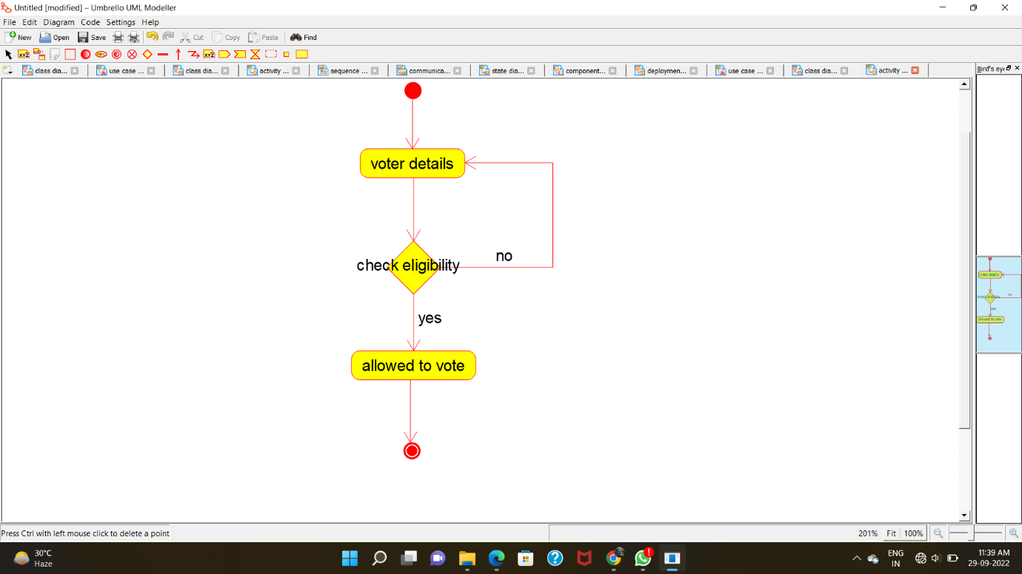

**SEQUENCE DIAGRAM:**

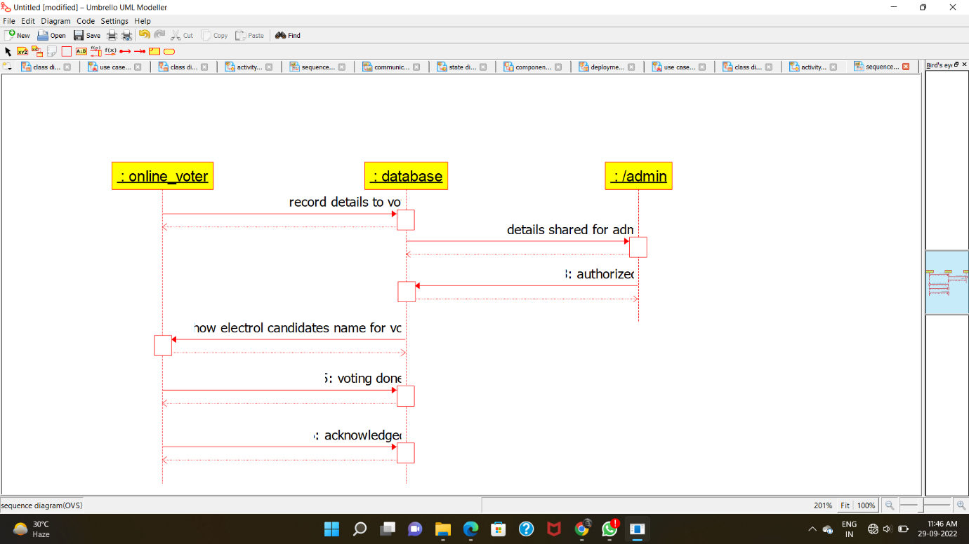

**COLLABORATION DIAGRAM:**

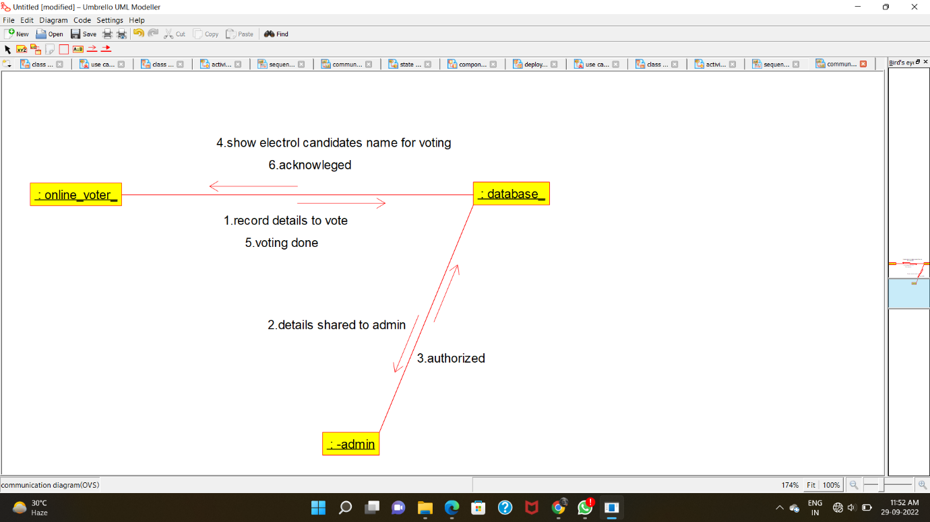

**STATE-CHART DIAGRAM:**

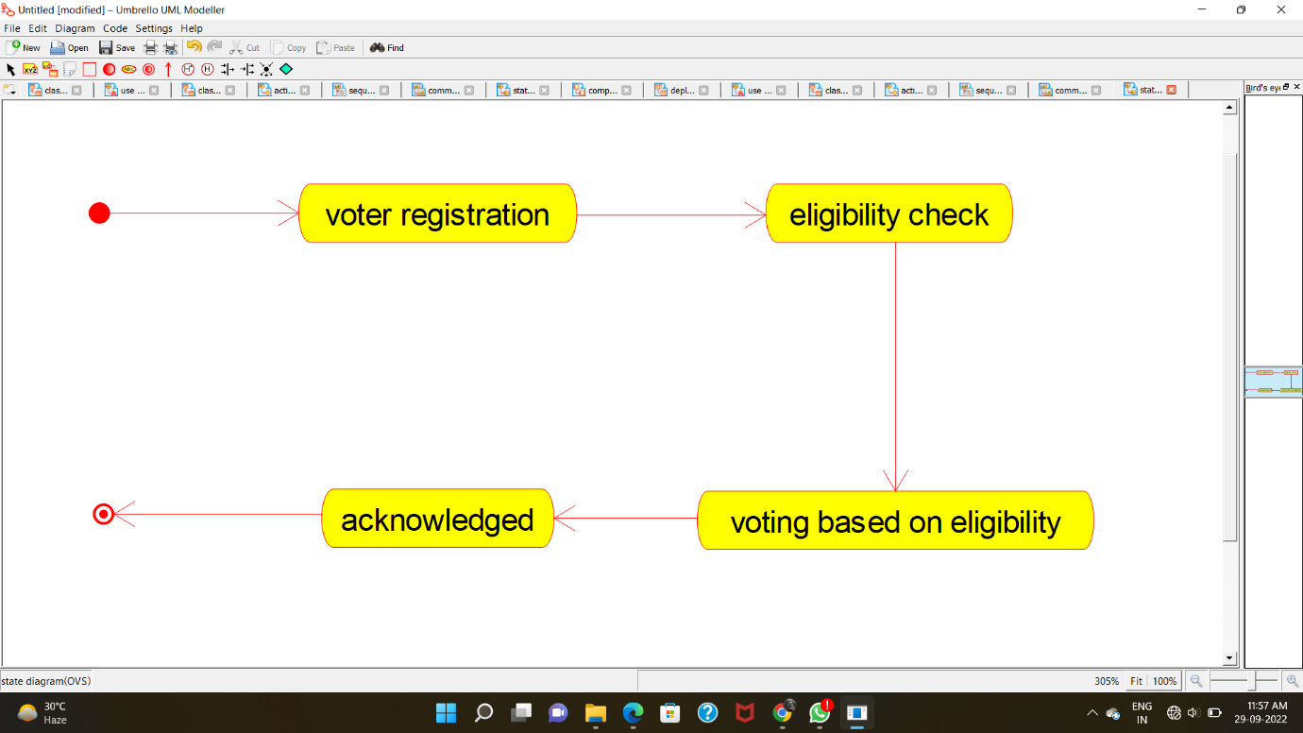

**COMPONENT DIAGRAM:**

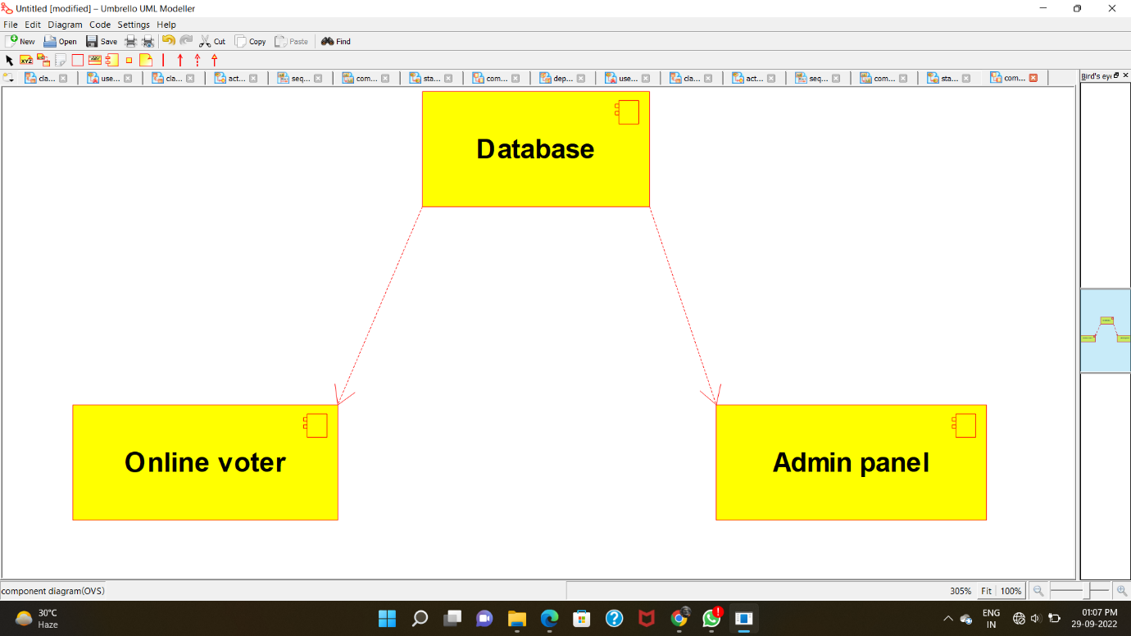

**DEPLOYMENT DIAGRAM:**

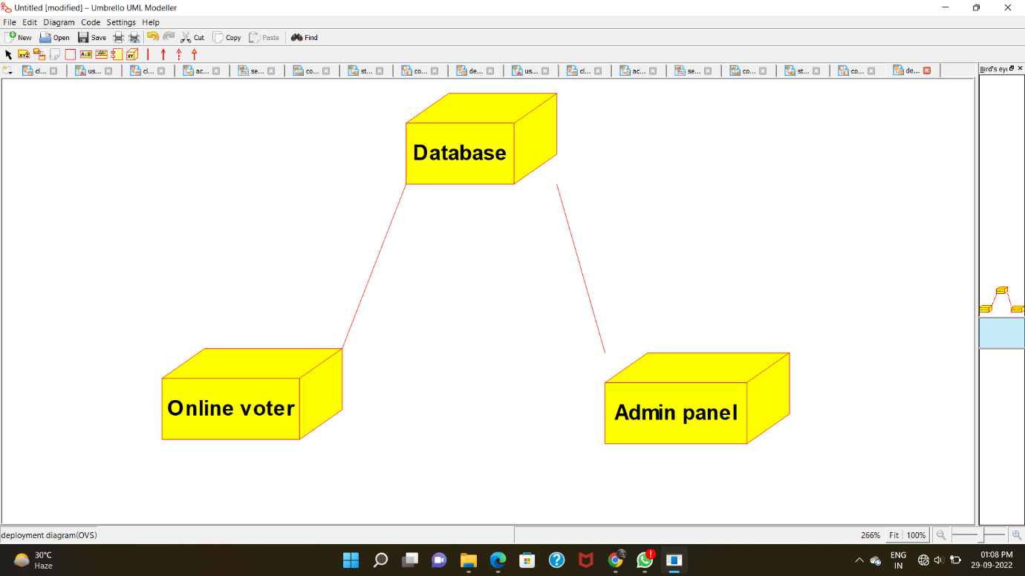

**PROGRAM CODE:**

**CENTRAL DATABASE:**

**/\*\***

**\* Class central_database**

**\*/**

**public class central_database {**

**//**

**// Fields**

**//**

**private void voter_details;**

**private void electoral_details;**

**private void eligibility_info;**

**//**

**// Constructors**

**//**

**public central_database () { };**

**//**

**// Methods**

**//**

**//**

**// Accessor methods**

**//**

**/\*\***

**\* Set the value of voter_details**

**\* @param newVar the new value of voter_details**

**\*/**

**private void setVoter_details (void newVar) {**

**voter_details = newVar;**

**}**

**/\*\***

**\* Get the value of voter_details**

**\* @return the value of voter_details**

**\*/**

**private void getVoter_details () {**

**return voter_details;**

**}**

**/\*\***

**\* Set the value of electoral_details**

**\* @param newVar the new value of electoral_details**

**\*/**

**private void setElectoral_details (void newVar) {**

**electoral_details = newVar;**

**}**

**/\*\***

**\* Get the value of electoral_details**

**\* @return the value of electoral_details**

**\*/**

**private void getElectoral_details () {**

**return electoral_details;**

**}**

**/\*\***

**\* Set the value of eligibility_info**

**\* @param newVar the new value of eligibility_info**

**\*/**

**private void setEligibility_info (void newVar) {**

**eligibility_info = newVar;**

**}**

**/\*\***

**\* Get the value of eligibility_info**

**\* @return the value of eligibility_info**

**\*/**

**private void getEligibility_info () {**

**return eligibility_info;**

**}**

**//**

**// Other methods**

**//**

**/\*\***

**\*/**

**public void get_voter_details()**

**{**

**}**

**/\*\***

**\*/**

**public void display_candidate_info()**

**{**

**}**

**/\*\***

**\*/**

**public void record_eligibility_permit()**

**{**

**}**

**ONLINE VOTER:**

**/\*\***

**\* Class online_voter**

**\*/**

**public class online_voter {**

**//**

**// Fields**

**//**

**private void details;**

**private void cast_vote;**

**//**

**// Constructors**

**//**

**public online_voter () { };**

**//**

**// Methods**

**//**

**//**

**// Accessor methods**

**//**

**/\*\***

**\* Set the value of details**

**\* @param newVar the new value of details**

**\*/**

**private void setDetails (void newVar) {**

**details = newVar;**

**}**

**/\*\***

**\* Get the value of details**

**\* @return the value of details**

**\*/**

**private void getDetails () {**

**return details;**

**}**

**/\*\***

**\* Set the value of cast_vote**

**\* @param newVar the new value of cast_vote**

**\*/**

**private void setCast_vote (void newVar) {**

**cast_vote = newVar;**

**}**

**/\*\***

**\* Get the value of cast_vote**

**\* @return the value of cast_vote**

**\*/**

**private void getCast_vote () {**

**return cast_vote;**

**}**

**//**

**// Other methods**

**//**

**/\*\***

**\*/**

**public void share_the_details()**

**{**

**}**

**/\*\***

**\*/**

**public void cast_the_vote_for_favorite_party()**

**{**

**}**

**}**

**ADMIN:**

**/\*\***

**\* Class admin_**

**\*/**

**public class admin_ {**

**//**

**// Fields**

**//**

**private void collect_details;**

**private void check_eligibility;**

**//**

**// Constructors**

**//**

**public admin_ () { };**

**//**

**// Methods**

**//**

**//**

**// Accessor methods**

**//**

**/\*\***

**\* Set the value of collect_details**

**\* @param newVar the new value of collect_details**

**\*/**

**private void setCollect_details (void newVar) {**

**collect_details = newVar;**

**}**

**/\*\***

**\* Get the value of collect_details**

**\* @return the value of collect_details**

**\*/**

**private void getCollect_details () {**

**return collect_details;**

**}**

**/\*\***

**\* Set the value of check_eligibility**

**\* @param newVar the new value of check_eligibility**

**\*/**

**private void setCheck_eligibility (void newVar) {**

**check_eligibility = newVar;**

**}**

**/\*\***

**\* Get the value of check_eligibility**

**\* @return the value of check_eligibility**

**\*/**

**private void getCheck_eligibility () {**

**return check_eligibility;**

**}**

**//**

**// Other methods**

**//**

**/\*\***

**\*/**

**public void get_the_details()**

**{**

**}**

**/\*\***

**\*/**

**public void check_the_eligibility_and_permit()**

**{**

**}**

**}**